Student Work Protocol

Subject Area: Painting I
Grade Level: Secondary
Formative or Performance Task: Mandala Painting

Reaching Consensus about Proficiency

For this project the students are expected to create a mandala painting. The mandala is required to have a form of symmetry and color. Within the painting students are expected to use forms of iconography or symbols, which relate and have personal meaning. Students are expected to do research to find inspiration for symbols and design.

Standards:
Observe and Learn to Comprehend:
- Visual art has inherent characteristics and expressive features
- Historical and cultural context are found in visual art
- Art and design have purpose and function
Envision and Critique to Reflect:
- Reflective strategies are used to understand the creative process
- Interpretation is a means for understanding and evaluating works of art
Intent and Discover to Create:
- Demonstrate competency in traditional and new art media, and apply appropriate and available technology for the expression of ideas
- Assess and produce art with various materials and methods
Relate and Connect to Transfer:
- Communication through advanced visual methods is a necessary skill in everyday life

A proficient response for this project is a completed painting of a mandala with personal meaning, in-class effort during studio hours, proficient planning and research, and participation in class critique. During the critique studnets are expected to discuss and analyse another classmates painting using formal art terminology.

Diagnosing Student Strengths and Needs

High  (Objectives met) | Expected  (Objectives partially met) | Low  (Objectives not met)
Kylie Bergey | Bryce Dahl | Alani Lang
Averee Gray | Rene Castillo | Jackson Herron
Rebecca Hennings | Alexandria Day | Dylan Lawler
Sydney Leighton | Kaylee Echard | Elijah Schaefer
Morgan Lessman | Carolyn Keating
AJ Ridley | Payton Bies
 | Shayly Smith
 | Talaya Treat
 | Jordan Tyler
32 % of Class | 47% of Cass | 21% of Class

Student Work Examples

High  (Objectives met) | Expected  (Objectives partially met) | Low  (Objectives not met)
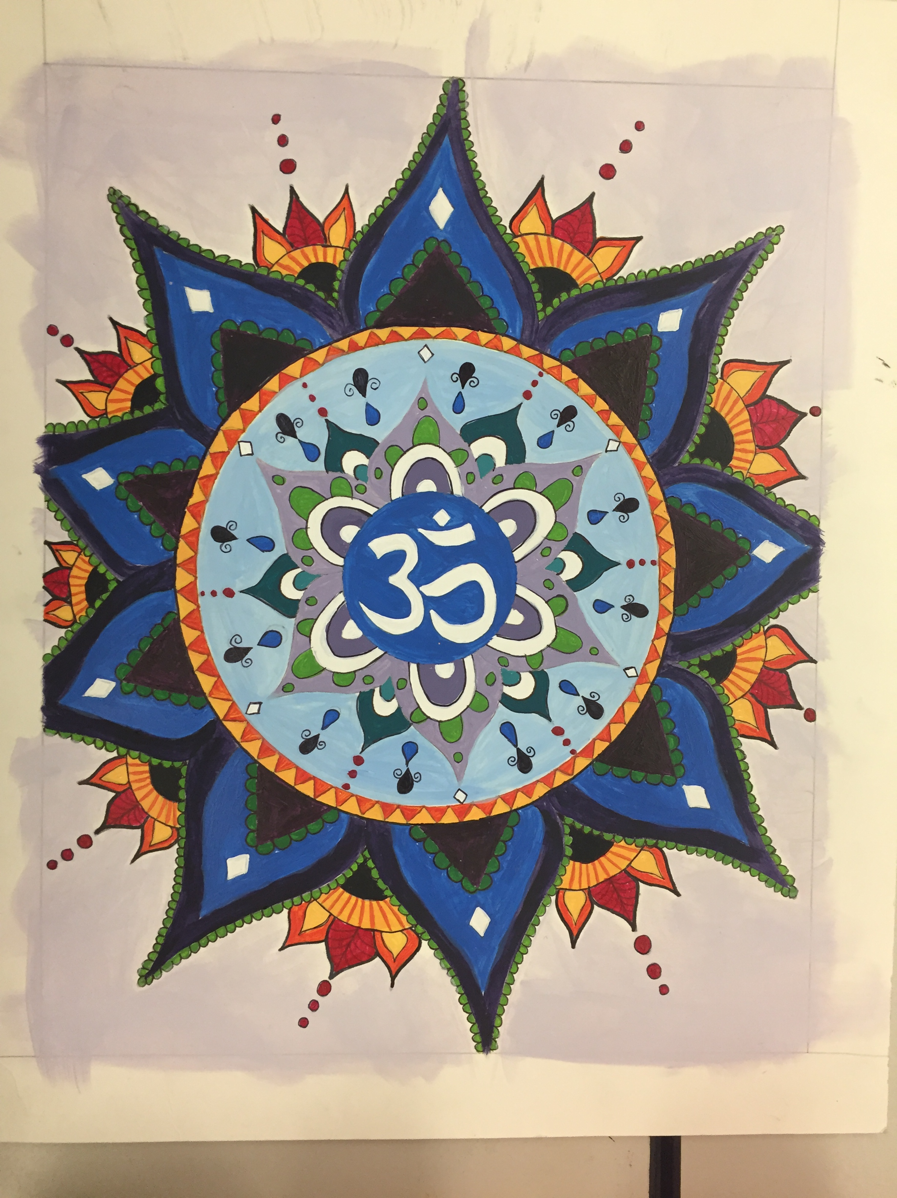 | 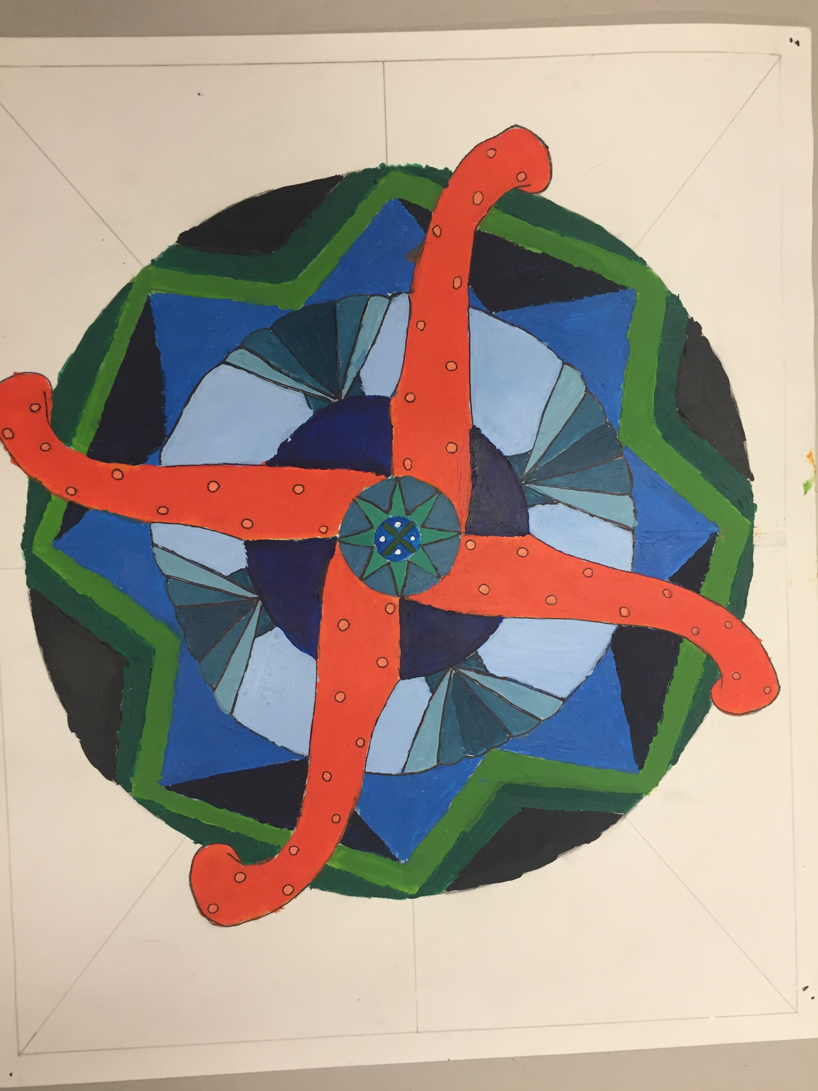 | 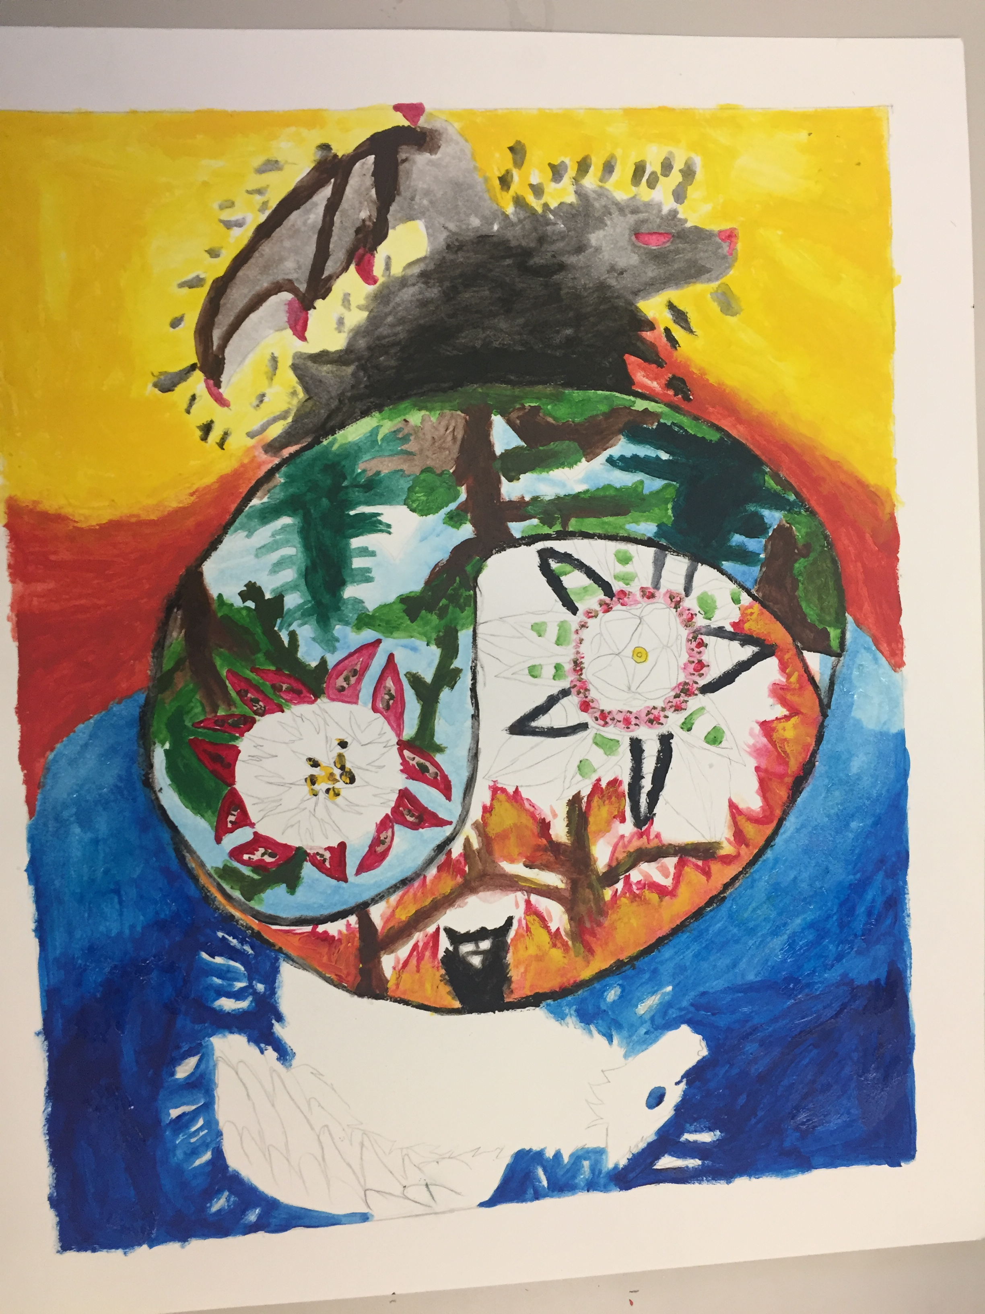

Reviews

High  (Objectives met) | Expected  (Objectives partially met) | Low  (Objectives not met)
This student demonstrated everything expected for the project and more. She went above and beyond the basic expectations | This student had a basic understanding of the project. They met the requirement of using symbols and adding personal identity to the work. They could have stretched it further when looking at shape, form, line, and color. The student shows an understanding of radial symmetry and the overall concept of the mandala design. | This student did not complete her project. There is little attention to detail and a rough overall look to the work. The student’s misconceptions lie within radial symmetry where the student fell short. She has good use of color, but her symbols are undeveloped and there is a lack of research and planning.

Identifying Instructional Next Steps

For the most part the majority of the class finished their work and fell into the expected category. This is a positive note that most of the student worked diligently of their project. Some of the students didn’t finish which landed them in the low achievement category. Matt Crawford has a policy implemented that students can return in their work for a better grade up until the end of the semester. This policy is beneficial for those students who work at a slower pace compared to other students.

3 Instructional Strategies:

Mid-project silent critique gallery walk:
Student can assess and receive constructive criticism on their work. This will inspire students to get their paintings done, as well as see peers work though the process.

PowerPoint Presentation of previous students work:
This will give students examples of what is expected and what is effectively achieved for above average work.

YouTube Video on mandala construction:
This will add use of technology to the lesson as well inspire students on professional grade work

High  (Objectives met) | Expected  (Objectives partially met) | Low  (Objectives not met)
 | Mid-project silent critique gallery walk | Mid-project silent critique gallery walk
 | PowerPoint Presentation of previous students work | PowerPoint Presentation of previous students work
YouTube Video on mandala construction | YouTube Video on mandala construction | YouTube Video on mandala construction

